Technical Story Card

Revision History
Version No. | Date | Prepared by / Modified by | Significant Changes

Glossary
Abbreviation | Description
BSC | Business Story Card
TSC | Technical Story Card

Table of Contents
1 Introduction 3
2 Scope of Change 3
3 List of impacted modules 3
4 Design and Detailed technical updates 4
4.1 Process model 4
4.1.1 Use case Model 4
4.1.2 Sequence diagram 4
4.2 Proposed user Interface design 4
4.3 Database design changes 4
4.4 Refactoring related changes 4
4.5 Construction strategy and re-use 4
5 Details of Alternative Design Approach 4
6 Other Technical changes 5
6.1 Automation tasks / changes 5
6.2 CI / Build relates tasks / changes 5
6.3 Non-functional related changes 5
7 Additional details 5
7.1 Open Questions / clarifications / Assumptions 5
7.2 Additional notes to technical team 5
8 References 5

Introduction
Our proposed system is an online food ordering system that enables ease for the customers. It overcomes the disadvantages of the traditional queueing system. Our
proposed system is a medium to order online food hassle free from restaurants as well as mess service. This system improves the method of taking the order from customer. The online food ordering system sets up a food menu online and customers can easily place the order as per their wish. Also with a food menu, customers can easily track the orders. The payment can be made online or pay-on-delivery system. For more secured ordering separate accounts are maintained for each user by providing them an ID and a password.

The Online Food Order System In Java is a simple project developed using java, Angular, and CSS, Hibernate, Oracle and Spring. The project connects different restaurants with customers. The project contains an admin , the user side and a payment gateway. All the management like editing site contents, updating food items, adding restaurants, and checking order status can be managed from the admin side. There can be many managers on the site.

For the user section, the users can go through the homepage, about, and contact pages. In order to order the food items, the user has to create an account and sign in or log in. The food comes with the cost as well. This project makes a convenient way for customers to buy/purchase food online, without having to go to the restaurant.

The design of this system is simple so that the user won’t get any difficulties while working on it. This system is for making efficient communication between
consumer and producer of the food system which will then leads to the ideal and effective system.

Scope of Change
Change will be done if required and it is done only from the admin side.

List of impacted modules
All the functional modules will be created from scratch.

The project contains an admin and the user and a payment gateway. All the management like editing site contents, updating food items, adding restaurants, and checking order status can be managed from the admin . There can be many managers on the site.

For the user section, the users can go through the homepage, about, and contact pages. In order to order the food items, the user has to create an account and sign in or log in. The food comes with the cost as well. This project makes a convenient way for customers to buy/purchase food online, without having to go to the restaurant.

For the payment’s gateway, the user has to enter the way of payment either by debit card or credit card. The user has to enter his/her card number, expiry date and the CVV number mentioned on the card. After clicking on submit button , they will get acknowledgment for the same.

Design and Detailed technical updates

Process model

ER Diagram

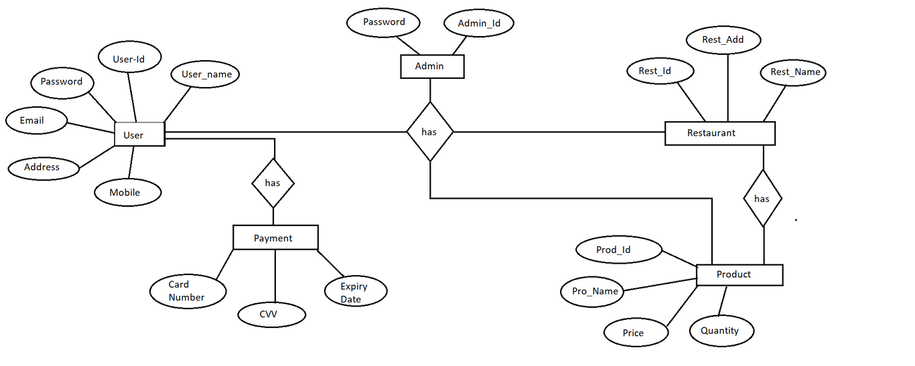

Sequence diagram
<Update the sequence diagram on how processes operate with one another and in what order and intent of changes / requirements proposed in the story >

Proposed user Interface design
<Document the various interfaces available to the user through this story and module>

Database design changes
<Provide the logical design of the base data structures used to store the data. E.g. Like tables, and views or entities and relationships>

Refactoring related changes
<Mention details of code re-factoring requirements; objective and scope of re-factoring and Changes to be done >

Construction strategy and re-use
< Mention about automated code development (using code-generator) or manual coding. Also identify make/buy/reuse components involved, if any >

Details of Alternative Design Approach
<Details of the alternative approach to resolve the maintenance request>

Other Technical changes

Automation tasks
<if the story is about automation (of test cases or some POC etc.), mention the details here>

CI / Build relates tasks
<If the story requirements are about implementation of continuous integration or build, update the details to be done here>

Non-functional related changes
<Non-functional requirements related to response time, System load or Network load>

Additional details

Open Questions / clarifications / Assumptions
<Mention the details of any open technical questions/clarifications or assumptions made, pertaining to story >

Additional notes to technical team
<provide details if any>

References
< Provide reference details if any >

